Problem Statement:

**Demonstrate the constraints for Employee DB.**

1. CREATE DATABASE

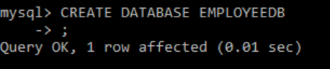

1. CREATE TABLE FOR ENTITY (PRIMARY KEY, FOREIGN KEY, NOT NULL, CANDIDATE KEY)

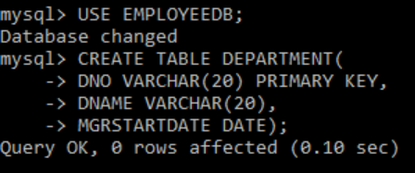

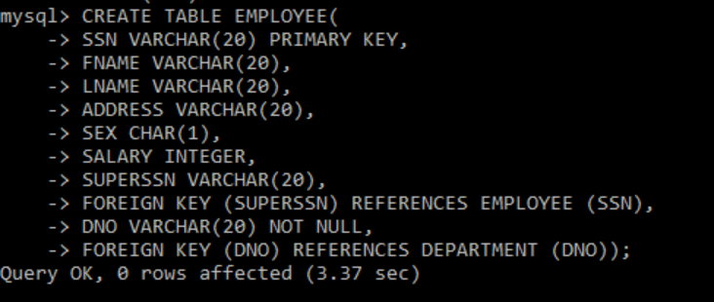



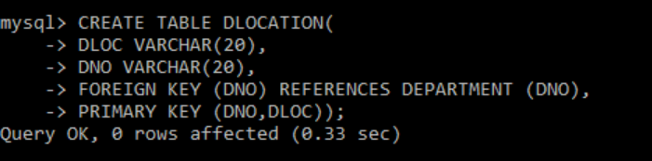

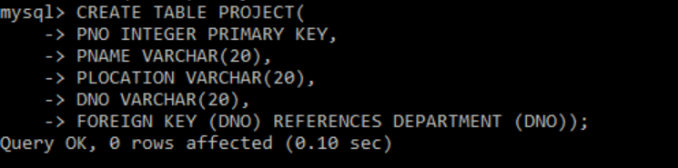

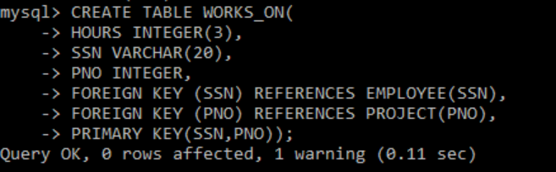

1. ALTER TABLE (MODIFY) WITH DEFAULT CONSTRATINT



1. DESC

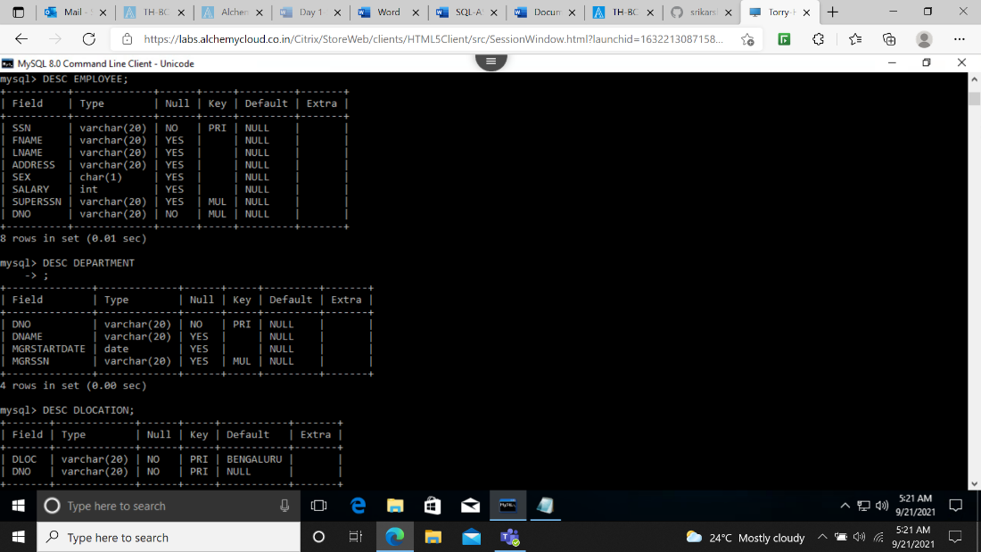

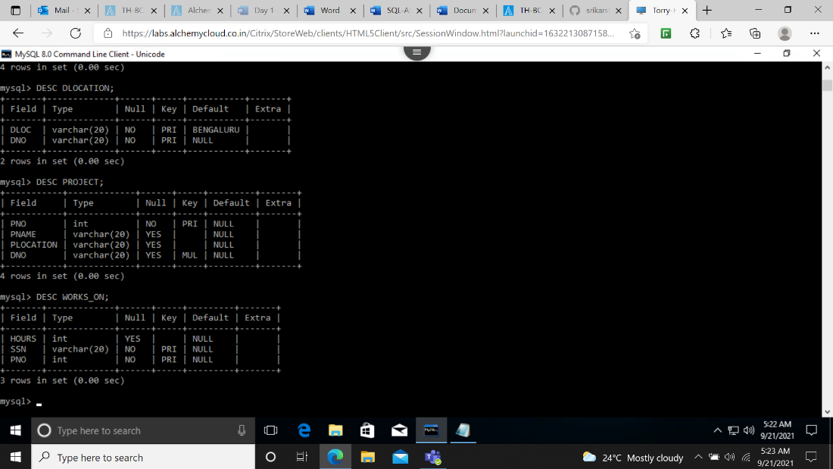

1. DELETE COMMAND



1. INSERT COMMAND

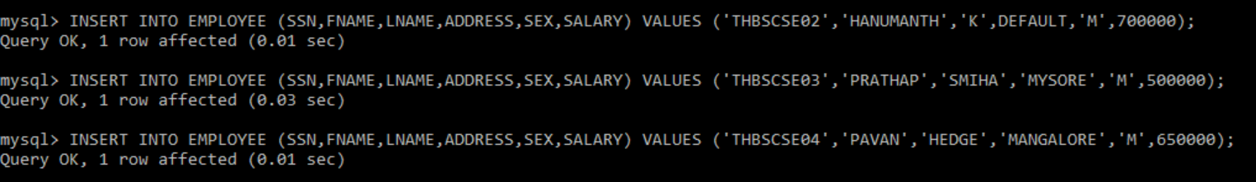

1. UPDATE COMMAND

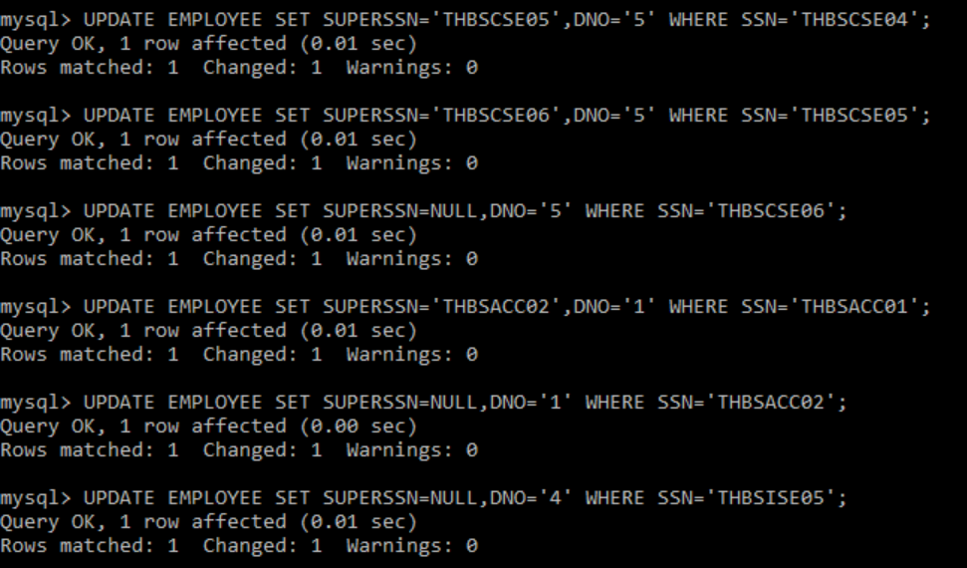

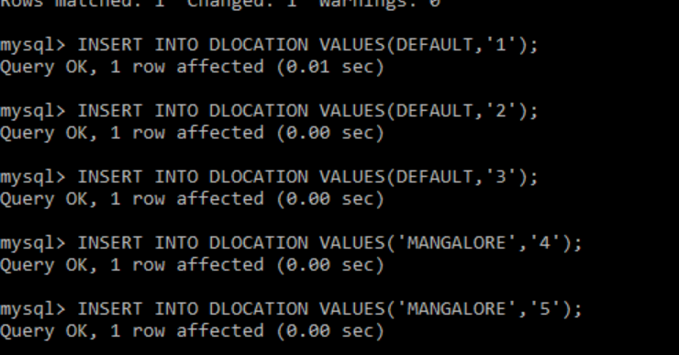

1. SELECT COMMAND

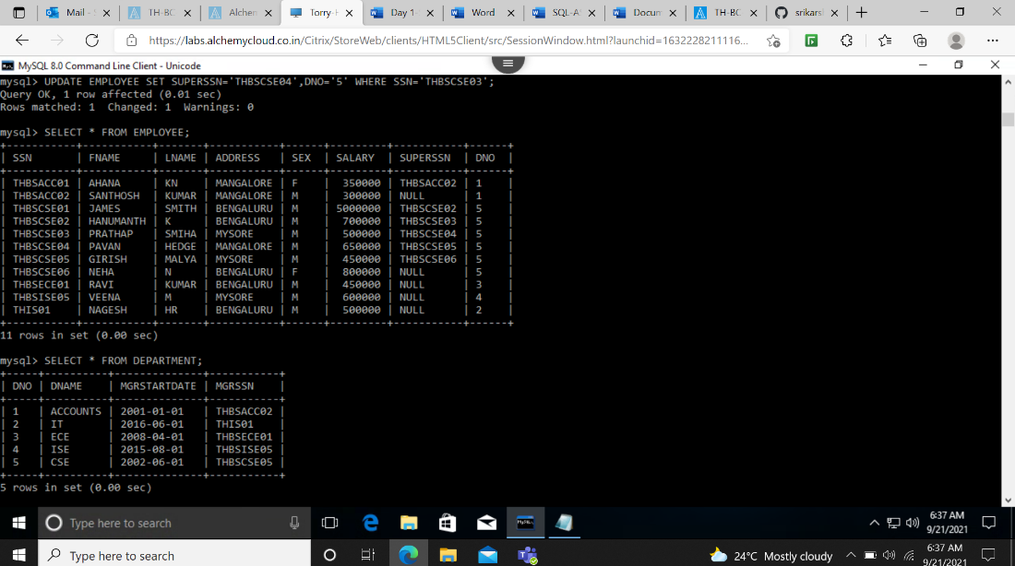

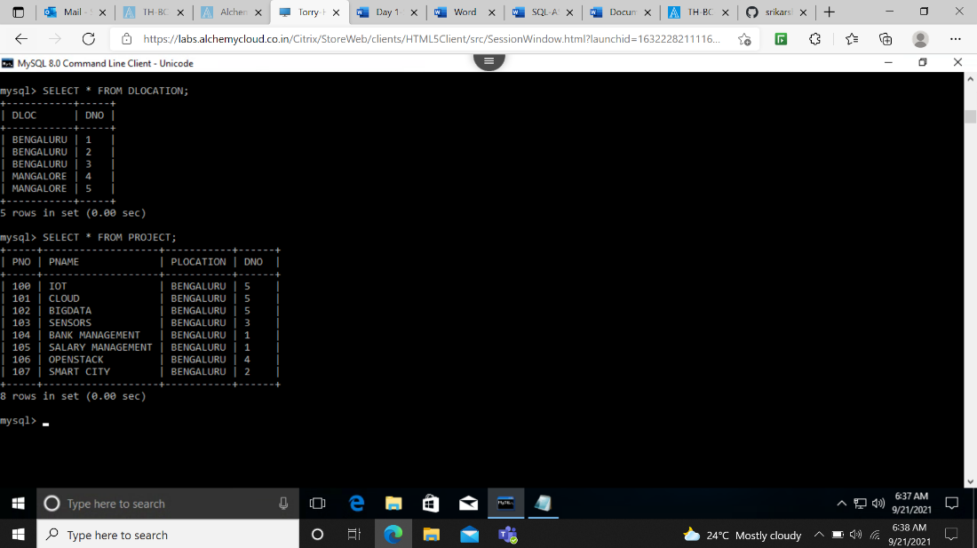

1. SELECT COMMAND WITH WHERE CLAUSE

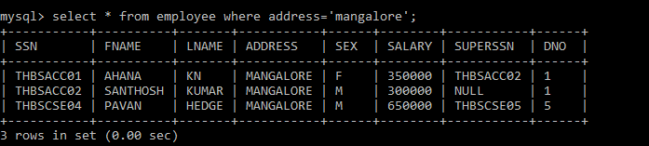

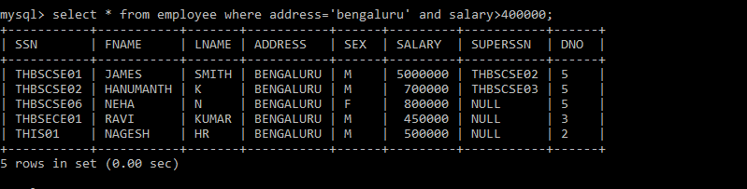

1. AGGRGATE FUNCTION – COUNT(), AVG(), SUM(), MIN(), MAX()

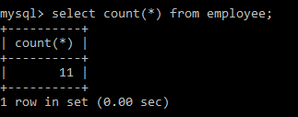

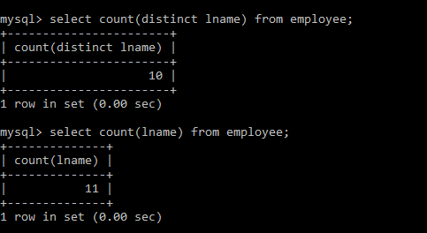

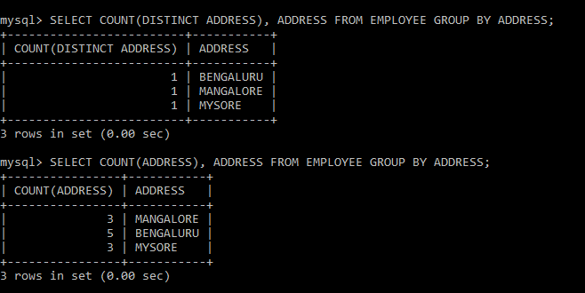

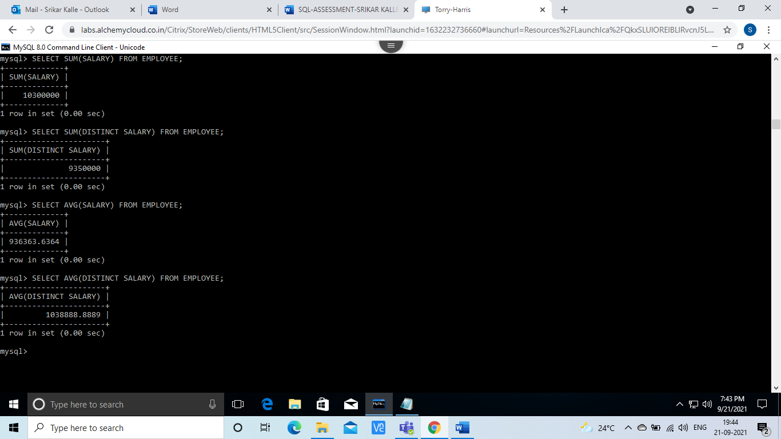

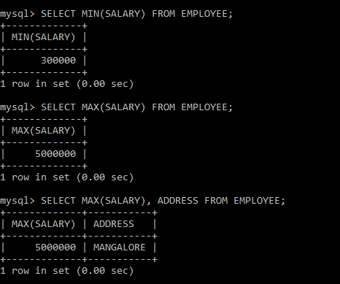

ORDER BY, GROUP BY

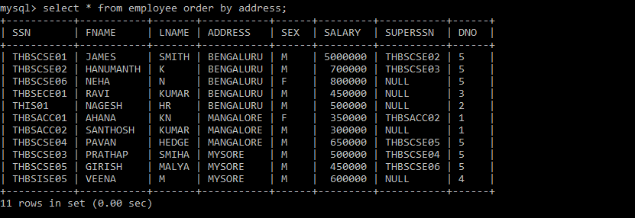

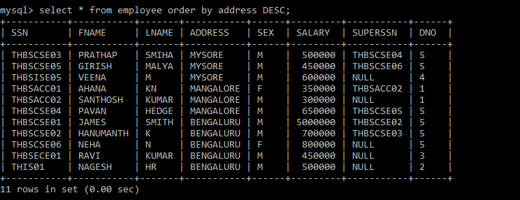

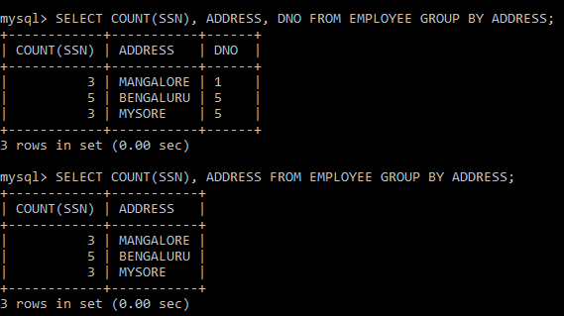

HAVING CLAUSE

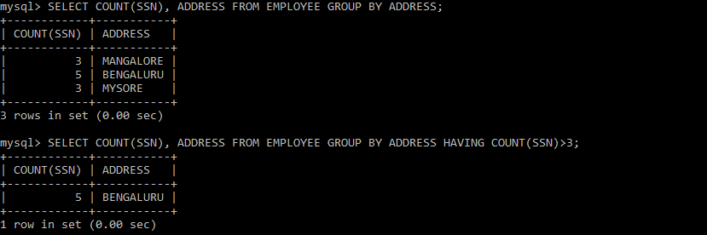

1. DROP TABLE

